Course 4

EC2 Instance :

course 3 e-shopping app

which contains backend as well as frontend folder

backend -🡪 spring boot 🡪 login micro service

frontend 🡪 angular 🡪 e-shopping-app

to run this application we already created docker-compose file

1. Copy and paste course 3 e-shopping app in different location which contains backend, frontend and docker-compose file.
2. From backend folder remove all folder except login-micro-service folder.
3. This project you need to push in your new remote repository.
   1. Open terminal inside course 3 e-shopping app folder
   2. git init
   3. git add .
   4. git commit -m “Initial commit”
   5. please create remote repository in your git hub account
   6. then create token
   7. git remote add origin URLwithtoken
   8. git push -u origin HEAD
4. Now we will login to AWS account and we need to create EC2 instance.

We add EC2 instance with 2 CPU and

Instance type is t2.medium with 2 CPU and 4 GiB RAM

1. Once instance ready we need to open few ports numbers in security group

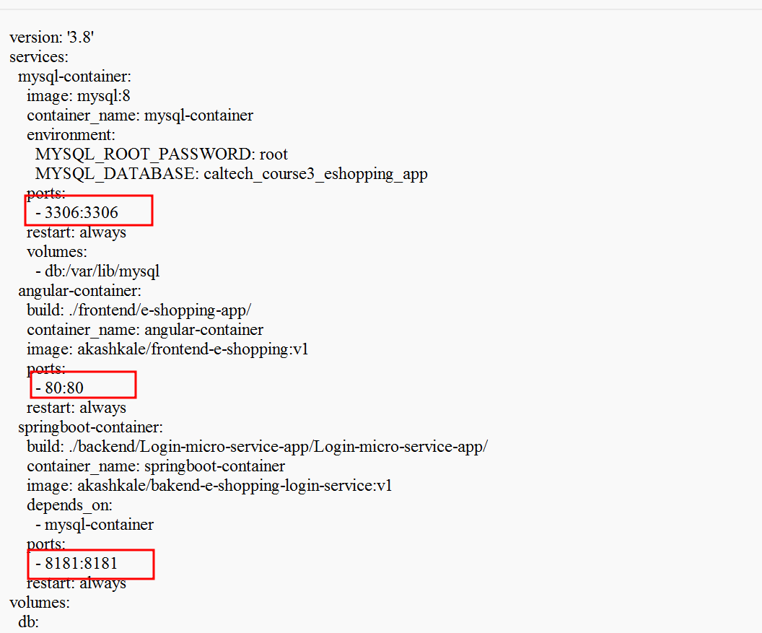

Inbound rules 8181, 80 for http protocol and mysql 3306 port number.

In EC2 instance by default every instance open default port number as 22 which is use for SSH client.

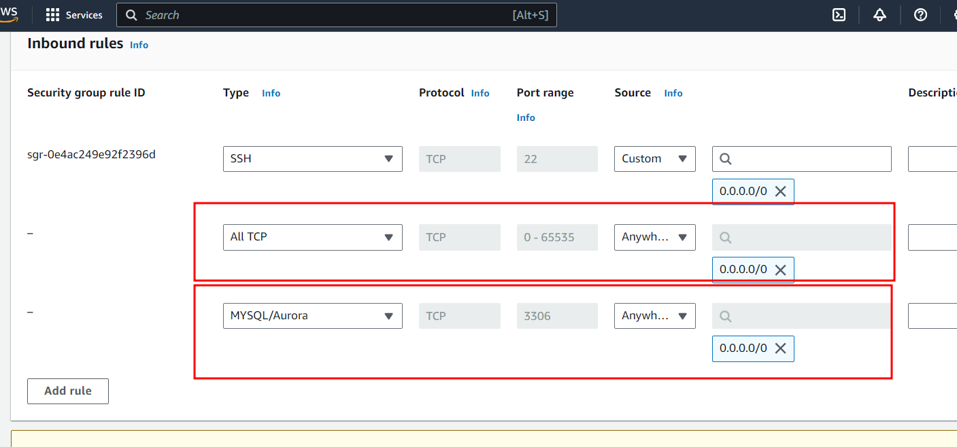

Now we need to connect EC2 instance

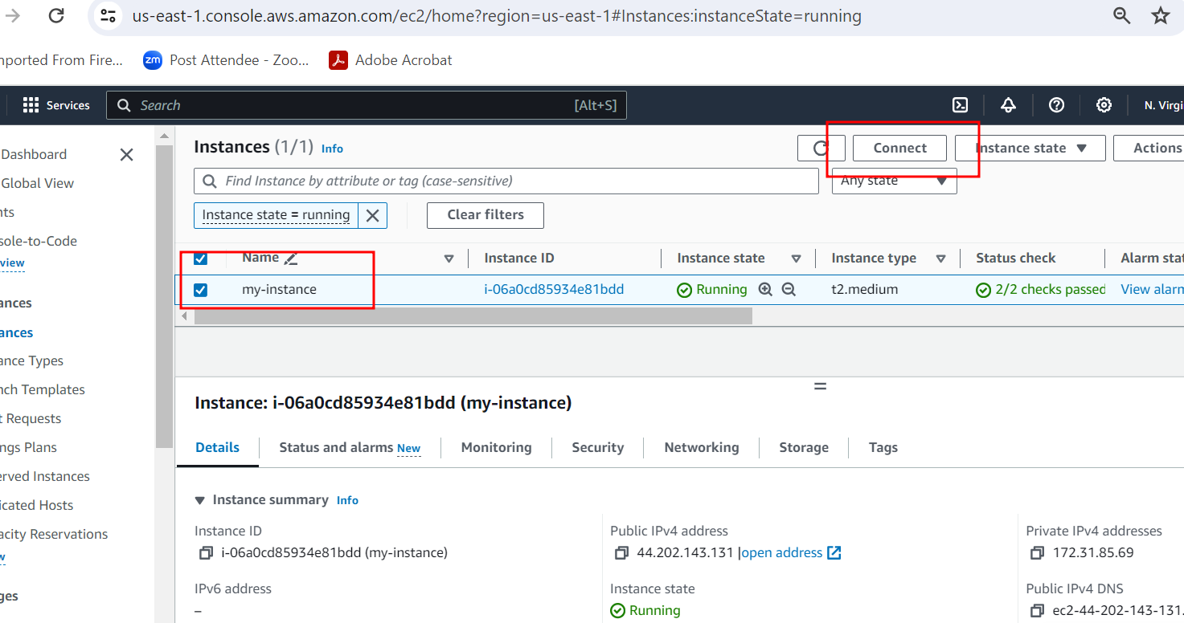

Connecting EC2 instance browser base

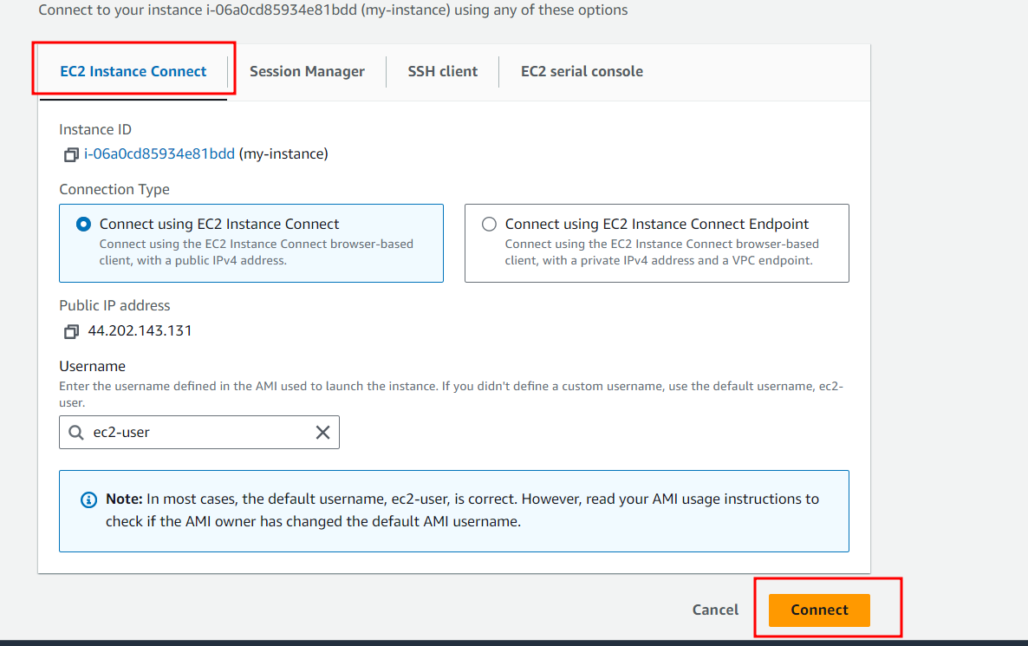

Using docker compose we can run three containers

Front end 🡪 angular

<http://localhost:8181> (spring boot login micro service)

Backend -🡪 spring boot

Mysql -🡪 database

Once we run docker-compose in EC2 instance frontend technologies is going to communicate with backend technology on EC2 instance with IP Address.

Now we need to open angular project in your machine and open service file and replace localhost by your EC2 instance IP Address.

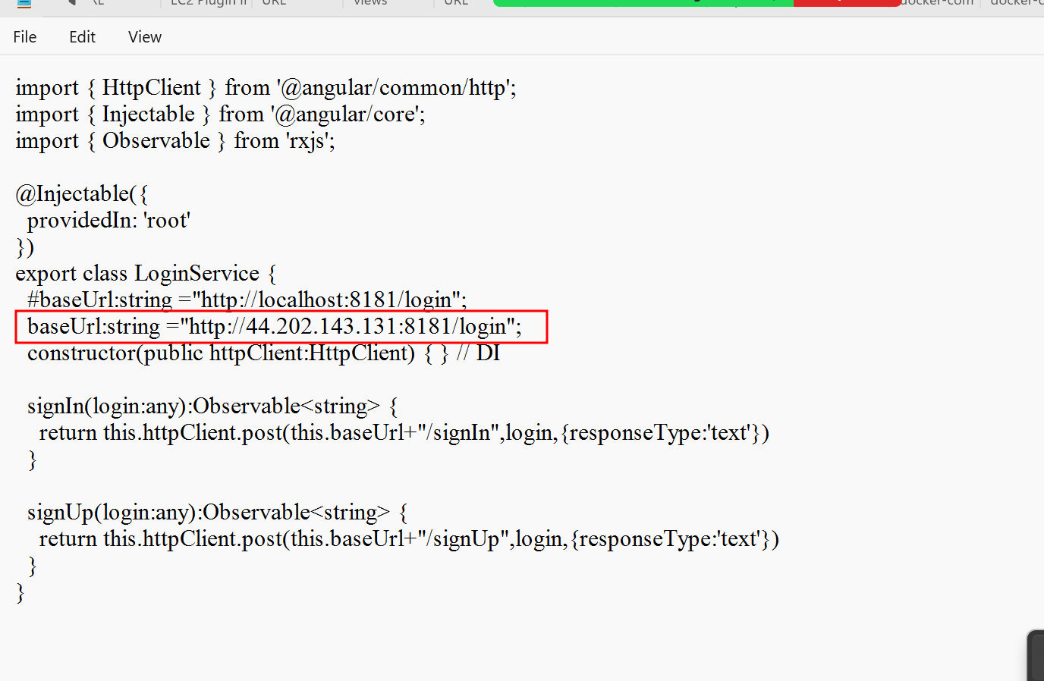

Once you done any changes in angular project or spring boot project we need to build the project once again.

We done some changes in angular project so inside angular project first run the command as

npm install (node_module)

ng build (to build the project)

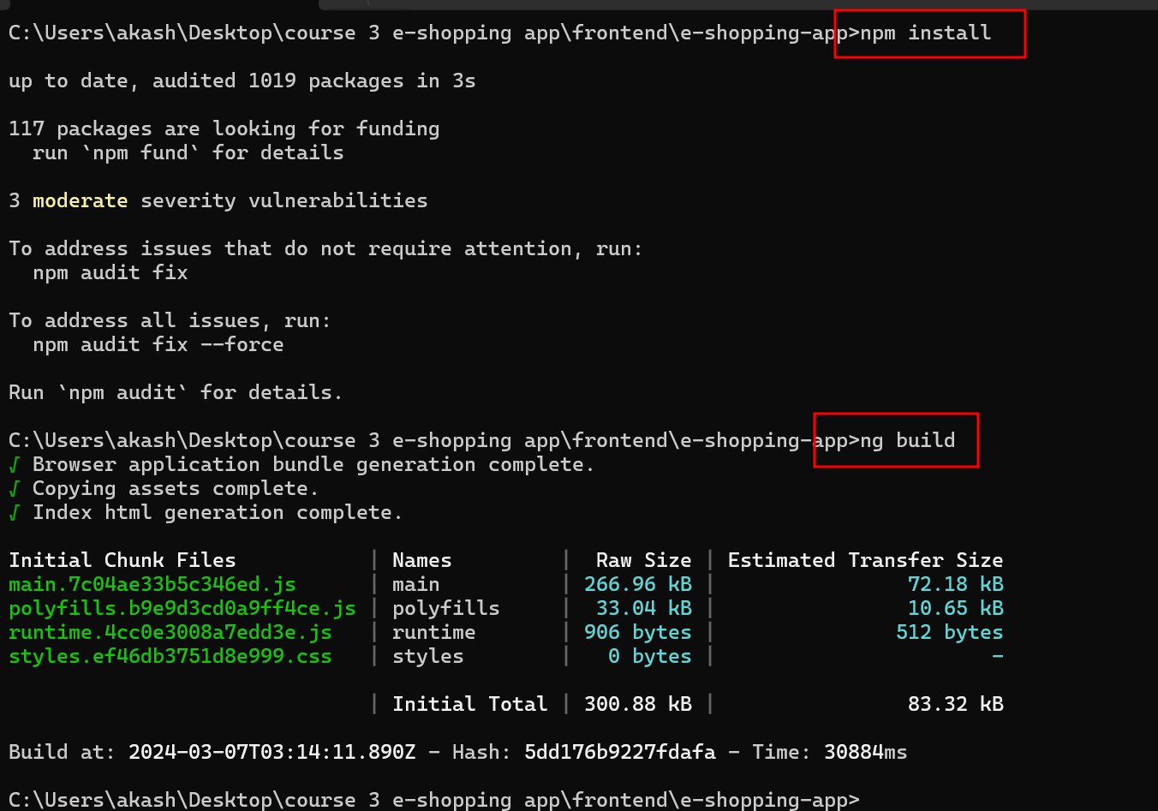

By default git ignore dist folder from angular project and target folder from spring boot project.

In frontend project open the .gitignore and remove dist folder from list.

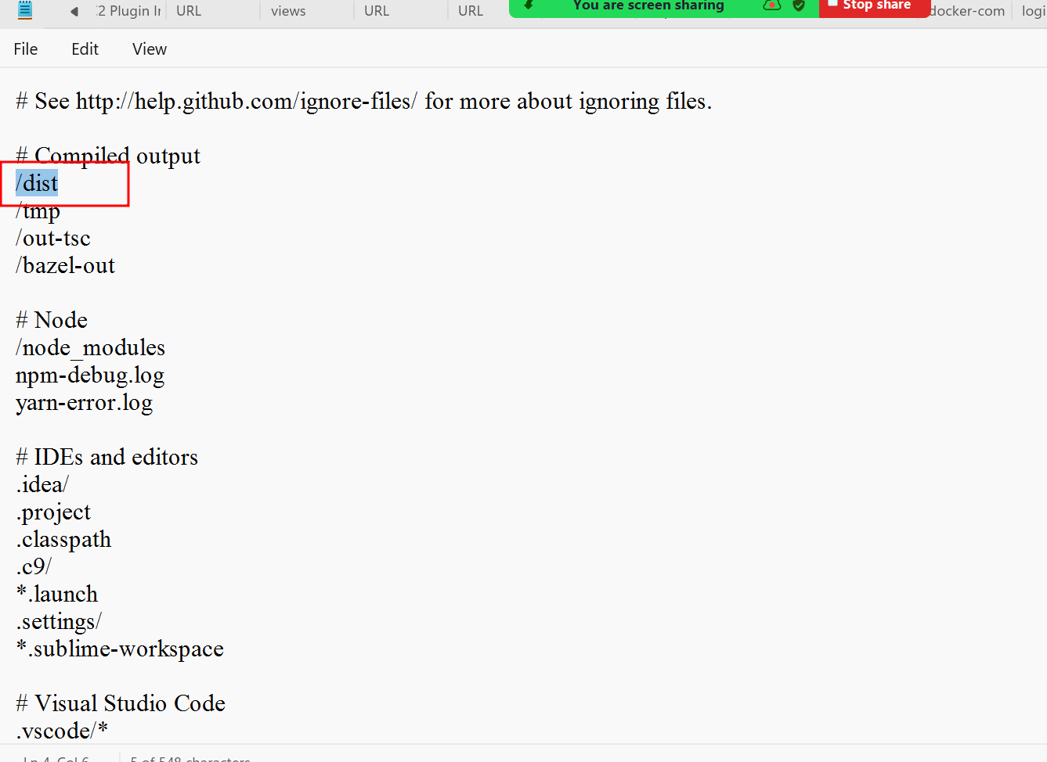

Remove dist folder path

In backend open .gitignore file and remove

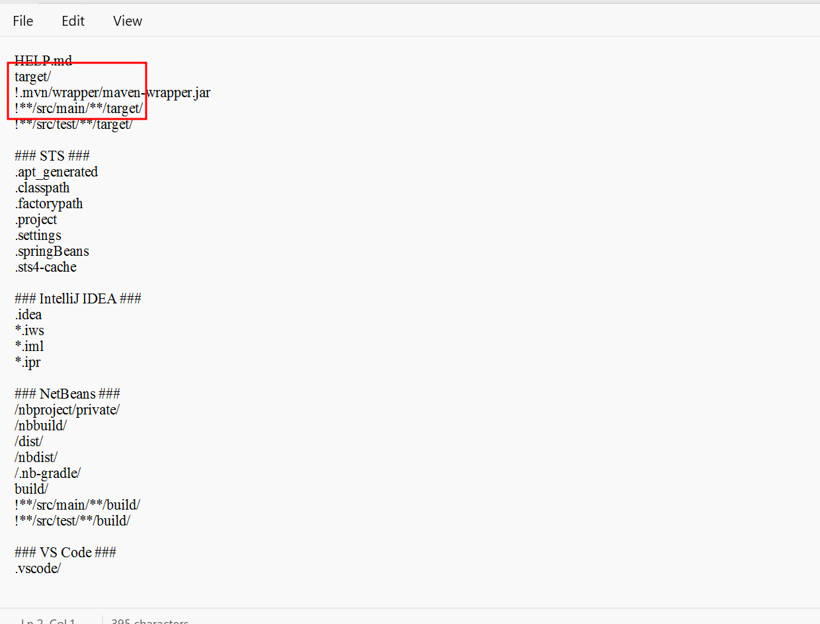

Remove target path

Once we re-build the project and remove all folder path from .gitingore please push your project to git hub account.

We need to install required software in EC2 instance

1. Git software
2. Docker software
3. Docker-compose

Docker desktop by default provide docker-compose toolkit.

Below command is use to install git, docker and docker-compose toolki

git install

sudo yum install git

install docker

sudo yum install docker

sudo service docker start

sudo docker info

Download the current stable release of Docker Compose

sudo curl -L https://github.com/docker/compose/releases/latest/download/docker-compose-$(uname -s)-$(uname -m) -o /usr/local/bin/docker-compose

Give the permission

sudo chmod +x /usr/local/bin/docker-compose

docker-compose –version

in Docker-compose in image section for both Spring boot and angular remove docker hub account name ie akashkale

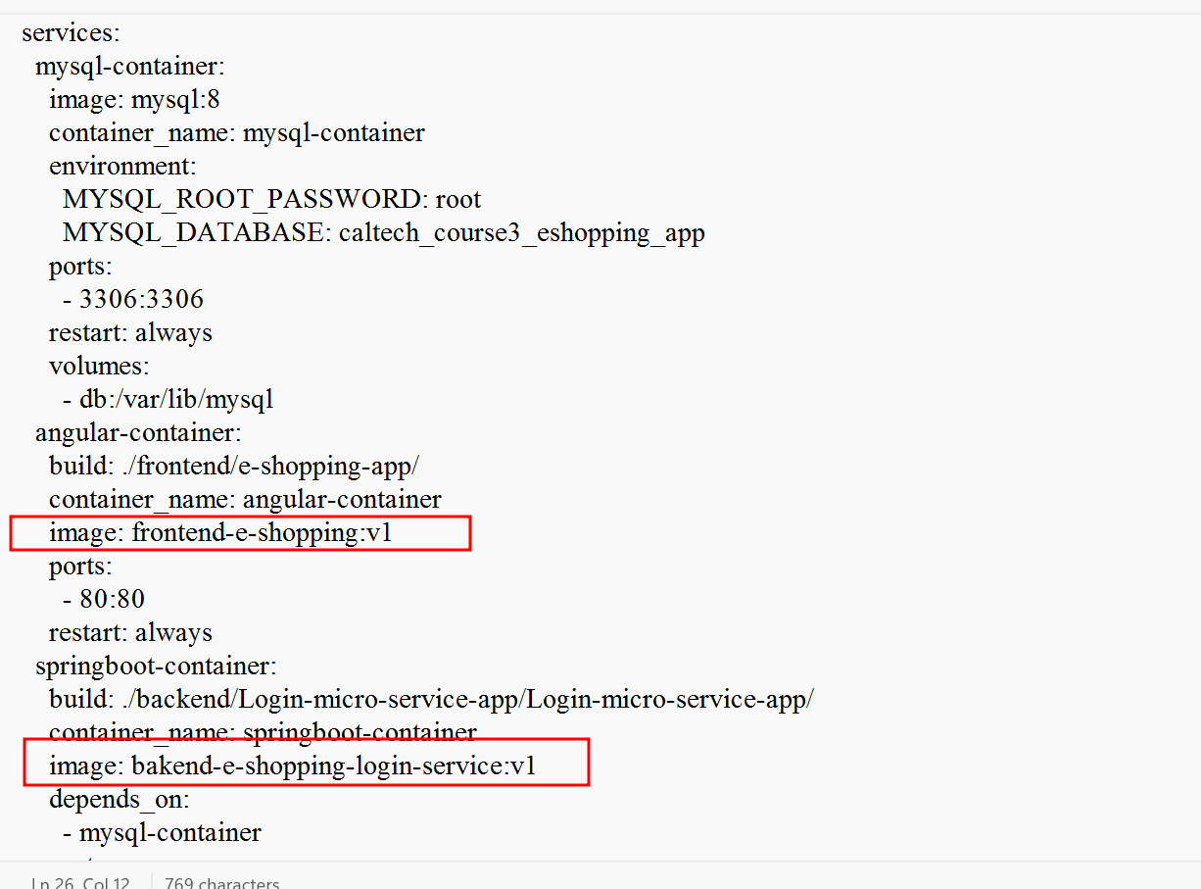

Now you need to pull project in EC2 instance using git clone URL

git clone <https://github.com/Kaleakash/e-shopping-app-demo.git>

cd e-shopping-app-demo

ls

docker-compose up –build -d

if you get any error for permission then run below command

sudo chmod 777 /var/run/docker.sock

then given permission to run docker using docker compose

then docker compose file

docker-compose up –build -d

after run successfully

docker images check all images are present or not

docker ps check all container running or not

then <http://publicIdAddress:80> 80 ngnix port number

if we want to check all table and database details running using container

first we need to find docker mysql container name using command as

docker ps

using below command we open mysql container os.

docker exec -it containerName/containerId bash

in terminal

mysql -u root -p

password : root

show databases

use caltech_course3_eshopping_app;

show tables;

select * from login